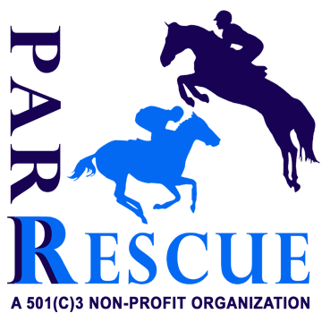
PA Racehorse Rehoming, Rehabilitation & Rescue (PARR) - Volunteer Agreement and Guidelines Statement

PARR’s farm manager or a board member will initially meet with and spend at least a few hours with each new volunteer in order to help assess volunteer’s comfort and experience level around the horses, farm and other animals, as well as their general mannerisms and work ethic. Volunteers will only be allowed on PARR property while farm management or a board member is also on site or if specifically arranged and agreed upon ahead of time with PARR representative. If any dangerous, careless or disrespectful behavior by a volunteer is observed or reported, the volunteer will immediately be asked to leave and is not invited to return unless agreed upon via unanimous decision by the PARR board members. Additionally, each volunteer must agree to these terms and sign a hold harmless agreement, to be kept on file, included below.

PARR Equine Activity & Canine Hold Harmless Agreement

I, (Name)_______________________________________________, the undersigned, have read, understand and freely and voluntarily enter into this Release and Hold Harmless Agreement with PA Racehorse Rehoming, Rehabilitation, Rescue (501c3 non-profit), Hillcrest Meadow Equine, Hillcrest Meadow Farm, and all volunteers, employees, owners, connections, trainers, and those involved, understanding that this Release and Hold Harmless agreement is a waiver of any and all liabilities. I understand the potential dangers that can be incurred while approaching, handling, riding, boarding, and feeding horses and or dogs. This includes, but is not limited to, interactions between horses, people or animals. Understanding these risks I hereby release Hillcrest Meadow, PARR, its employees and volunteers, owners and anyone else connected with Hillcrest Meadow/PARR from any liability, whatsoever, in the event of injury or damage of any nature both personal or to property, including death, to me or anyone else that arises from my owning or approaching any horses on this farm or any property we are on. This includes the owner of the horse, leasee/leasor, visitors, spectators or other riders.

I additionally understand that the PARR animals are often ex-racehorses or rescued horses, rescued/ neglected /abused dogs and their prior history is not always known. Their behavior may be unpredictable. Farm staff, management and other volunteers do their best to properly assess behavior and avoid injury, but the horses’ and dogs’ actions can and will be unpredictable and could result in injury or damage. Interaction with farm animals and riding is acknowledged to be done so AT YOUR OWN RISK.

This agreement releases any owners of property, horses, pets, Hillcrest Meadow / PARR, trainers, riders, employees, staff, spectators or visitors from any liability. The facility in which a horse is located at, including any farms that the horse is hauled over to, or public or privately owned properties where a horse or dog is located are included in this release of liability for injury, damage, or death.
You assume the risk of equine activities pursuant to Pennsylvania Equine Law.

Please Initial_______ YES, I certify that I am over the age of 18, have read and do fully understand and agree to above stipulations involving PARR and volunteering/interacting with the farm and animals and humans on-site.

SIGNED: _____________________________________ Date:________________________

*Equine experience level (circle): Beginner Intermediate Advanced/Professional

*Canine experience/comfort level (circle): Beginner Intermediate Advanced/Professional

* Rider Level – if trying/riding a horse (circle): Beginner Intermediate

Advanced/Professional
Printed Full Name and Email Address: ___________________________________________

Age:_______________ ***If you are under the age of 18, please have legal parent or guardian complete and initial and sign this form along with you, agreeing to and assuming the risks described on your behalf

Address:___________________________________________________________________

Phone Number/Cell:______________________________________________________________

Emergency Contact Info:

__________________________________________________________

